EbzB Productions - Your World Is Our Stage!

EbzB Productions Mission: EbzB Productions, Inc. strives to develop original, touring, theatrical productions to promote integrity, self-discovery and positive transformation of individuals, artists, audiences, and communities. We believe that the performing arts encourages positive transformation through discoveries unveiled immediately and upon reflection. EbzB artists are dedicated to the promotion of dramatic art as a valuable educational tool. We are trained by The John F. Kennedy Center For The Performing Arts "Artists as Educators: Planning Effective Workshops", and The Lincoln Center Institute's International Educator Program. EbzB Is also endorsed by the North Carolina Arts Council's Touring Artists Directory. In addition to performances, EbzB Productions, Inc. is available for student workshops, residencies, and professional development seminars.

Founded in 1998 by Serena Ebhardt and David zum Brunnen, EbzB Productions celebrates the profound impact of storytelling through theater in a repertoire of simple and compelling productions, flexibly designed for easy touring to all types of performance spaces.

The Founders: Serena Ebhardt and David zum Brunnen delight audiences on their frequent tours throughout the United States. This award-winning husband-wife, actor-manager team bring over forty years of experience to the stage. Their careers have taken them from off-Broadway and the U.S. to Canada and Europe. In addition to their EbzB resumes, the couple have appeared together in many productions, among which are Travesties, She Stoops To Conquer, Reckless, Cloud Nine, Nicholas Nickleby, The Rocky Horror Picture Show, The Cat and The Canary, Raney, Dearly Departed, and the off-Broadway American Premiere of Winding The Ball.

Our Name: The "Eb" in EbzB comes from the first two letters of the surname "Ebhardt" (Serena). The "zB" in EbzB come from the first letter in the surname prefix "zum" and first letter in the surname of "Brunnen" (David). Confusion has lead us to be called "EzBz", "EzB", "EBz", and even, "Heebie Jeebie". In reflection, many of the presenters we work with have suggested we shorten the name to EZ Productions, which we appreciate. However, we remain, EbzB Productions.

The Night Before Christmas Carol DVD of the national public television broadcast may be purchased after the performance or online at WWW.EBZB.ORG.

The Night BEFORE
Christmas Carol

By Elliot Engel

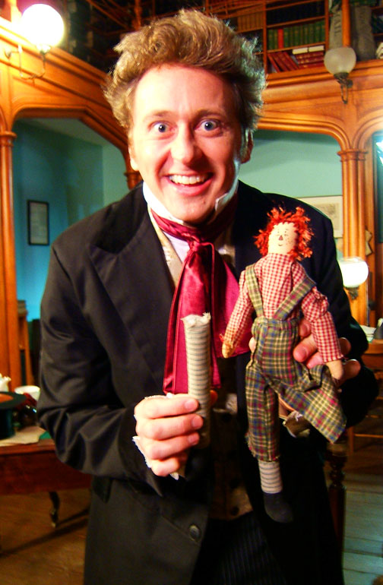

Featuring David zum Brunnen

Directed by Serena Ebhardt

Produced by EbzB Productions
www.EbzB.org

The Night Before Christmas Carol

Join Charles Dickens in his study on Friday, the thirteenth, 1843. History, humor and the holiday come to life in The Night Before Christmas Carol. Renowned Dickens scholar and author, Dr. Eliot Engel, crafts this entertaining study suitable for every holiday schedule and audience. In this acclaimed performance, actor David zum Brunnen portrays Charles Dickens and 17 familiar characters; giving personal, social, and historical context to the ghostly classic, A Christmas Carol.

DAVID ZUM BRUNNEN (CHARLES DICKENS)
David’s performance credits include: New York: Winding The Ball (American Premiere). Canada: Nicholas Nickleby in Nicholas Nickleby (Stephenville Festival, Canada), Charlie Brown in You’re a Good Man Charlie Brown; National Tour: Elliot Engel’s The Night Before Christmas Carol, The Tender Nights of F. Scott Fitzgerald, The Wrights of Passage. Regional: Kruger in The Front Page (under the direction of three-time Tony Award winner and film director, Gene Saks, for PlayMakers Repertory Company), The Author in Deep Dish Theater’s acclaimed production of Via Dolorosa; Henry Carr in Travesties (Piccolo Spoleto Festival); Comedy of Errors (Foundation Theatre, NJ), Mercutio in Romeo and Juliet (Birmingham Children's Theatre, AL); Hotspur and other roles in Henry IV, Parts I & II (Burning Coal Theatre Company). In addition, David may be seen in numerous films and TV commercials. David also excels at the balance between acting and managing. In addition to his performance skills, David has served as General Manager for Hedgerow Theatre, Philadelphia Area Repertory Theatre, and PlayMakers Repertory Theatre. He has also served as the Executive Director of the North Carolina Theatre Conference and has received two INDIE awards for enhancing the cultural life in the Triangle area of North Carolina. David is a member of Actors Equity Association and Screen Actors Guild.

"David [zum Brunnen] -- absolutely becomes my great-grandfather on stage!"

-Cedric Charles Dickens
Great Grandson of Author, Charles Dickens
DR. ELLIOT ENGEL (PLAYWRIGHT)
Originally from Indianapolis, Indiana, Dr. Engel now lives in Raleigh, North Carolina, where he has taught at the University of North Carolina, North Carolina State University, and Duke University. He earned his M.A. and Ph.D. as a Woodrow Wilson Fellow at UCLA. While at UCLA he won that university’s Outstanding Teacher Award. Dr. Engel has written ten books published in England, Japan, and the United States. His mini-lecture series on Charles Dickens ran on PBS television stations around the country. His articles have appeared in numerous newspapers and national magazines including Newsweek. He has lectured throughout the United States and on all the continents including Antarctica. Four of his plays have been produced during the last ten years. For his scholarship and teaching, Dr. Engel has received North Carolina’s Adult Education Award, North Carolina State’s Alumni Professorship, and the Victorian Society’s Award of Merit. Most recently, for his thirty years of academic work and service in promoting Charles Dickens, he was nominated and inducted into the Royal Society of Arts in England. Since 1980, Dr. Engel has been President of the Dickens Fellowship of North Carolina, the largest branch of this worldwide network of clubs. The sales of Dr. Engel’s books, CDs, and DVDs have raised funds for The Great Ormond Street Children’s Hospital which Dickens helped found in London in 1852. Professor Engel continues to teach outside the classroom and give literary and historical programs throughout the world. He also presents assemblies at elementary, middle, and high schools, and his educational CDs are used in classrooms around the country. In his spare time, he enjoys reading, walking, and vacationing in exotic locations where he is not asked to deliver even one lecture.

SERENA EBHARDT (DIRECTOR)
Serena is the co-founder of EbzB Productions. Her directing credits include National Tours: Dar He: The Murder of Emmett Till, War Bonds: The Songs and Letters of World War II, Blood Done Sign My Name, The Wrights of Passage, Anne Frank and The Best Christmas Pageant Ever. Regional: The Foreigner (Sandhills Theatre Company), Fit To Be Tied (Manbites Dog Theatre), The Long Christmas Dinner, A Christmas Memory (Hedgerow Theatre). University and Community: Search for Signs of Intelligent Life, Where It's All Warm and Secret, Chamber Music, and The Tempest. Serena also adapts, arranges and directs the offerings of EbzB Productions including Lewis and Clark: The Corps of Discovery, Nicholas Nickleby in One Hour with Two People, Brown v. Board of Education, War Bonds, In One Era and Out The Other, Madame Defarge's Tale of A-Tro-Cities, Sketches of Young Couples by Boz, Dickens: Food and Froth, and Marriage Vows and Modern Verbiage. Serena’s training includes The John F. Kennedy Center for The Performing Arts and the Lincoln Center Institute.

